

|  |  |  |  |  |  |  |  |  |
| --- | --- | --- | --- | --- | --- | --- | --- | --- |
|  | | | | | | | | |
|  | | Front-End Dev. Proj. Report | | | | |  | |
|  |  | | | | | | |  |
|  | | | |  |  | | | |
|  | | | | Vinuthna Sai Chitneni |  | | | |
|  | | | | Date : 01/12/2020—Front-end Web Development—Instructor: Kelvin Gao |  | | | |
|  | | |  | | |  | | |



|  |  |  |  |  |  |  |  |  |
| --- | --- | --- | --- | --- | --- | --- | --- | --- |
|  |  | | |  |  | | |  |
|  | INSTRUCTIONS | | | | | | |  |
|  |  | | |  |  | | |  |
|  |  | |  | | |  | |  |
|  |  |  | You need to submit this report with the images of the website design (Project Description Section 2.2) and all source codes and resource. You can also host your website online and submit the URL. | | |  |  |  |
|  | | | | |
|  |  |  |  |
|  |  |



|  |  |  |  |  |  |  |
| --- | --- | --- | --- | --- | --- | --- |
|  | |  |  |  |  | |
|  | | THE PROCESS | | |  | |
|  | |  |  |  |  | |
|  | Introduction Briefly describe your project here:   1. Which project do you choose?   I have selected project -1, front end web development to redesign the website of computer science department, AUM university.   1. Briefly discuss the front-end web development techniques that you use in the project.   I have used various techniques for front -end web development.   * HTML – I have used most of the HTML tags to design all the required pages of website. Initially, I have prepared header which demonstrate basic information of the site. Header is going to be repeated in all the pages of the website. There is the same story with the footer part but it contains copyright info and all. Using HTML I have prepared forms to take input from user in “Teaching application page” and “GPA calculator page”. * CSS – I have used external CSS files called “header.css” and “teaching.css” to dec0rate various html form fields, navigation menu and footer part. * JavaScript – I have used javascript in “Teaching application page” and “GPA calculator page” to read user input and display it after required logic implementation. | | | | |  |
|  | Implementation For Project I, describe the essential HTML elements (<a>, <h1>, <p> etc.), CSS properties and JavaScript (if applicable) for every page. Attach screenshots if necessary.  Html Elements used:    <link> - to include external css.  <img> - to include image of college logo.  <li> - to arrange titles in navigation bar.  <div> - to design individual section of data.  <footer> - to mention data in footer part.  <p> - to generate paragraph.  <h1> - to mention title in heading 1 size.  <form> - to create form.  <label> - to generate label in form.  CSS Tags used:  font-family: to set type of font.  margin: to set margin in layout.  border: to set the border size.  background-color: to set background color of the div.  text-align: to set text alignment.  color: to set font color.    Javascript tags used:  Function – to create user defined function.  Var – to declare variable  document.getElementById – to bind data from div id.  Screenshots --  Home page: | | | | |  |

Program Details:



Teaching Assistant application:

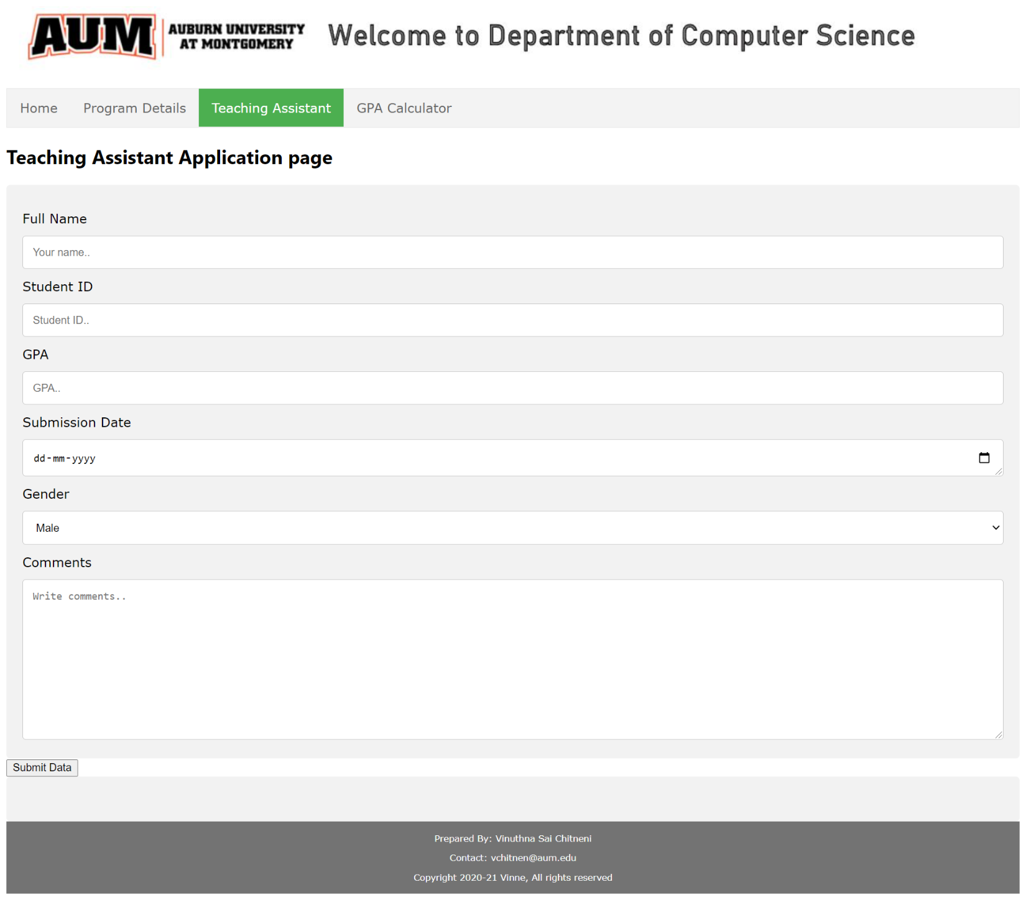

Display data of teaching assistant page:

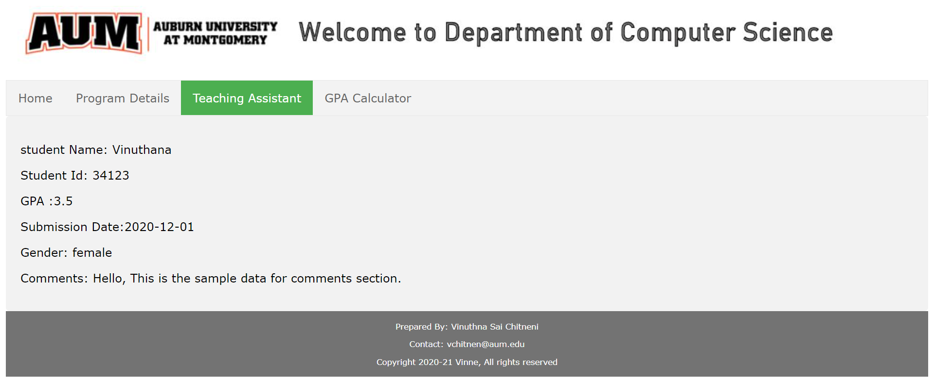

GPA calculator :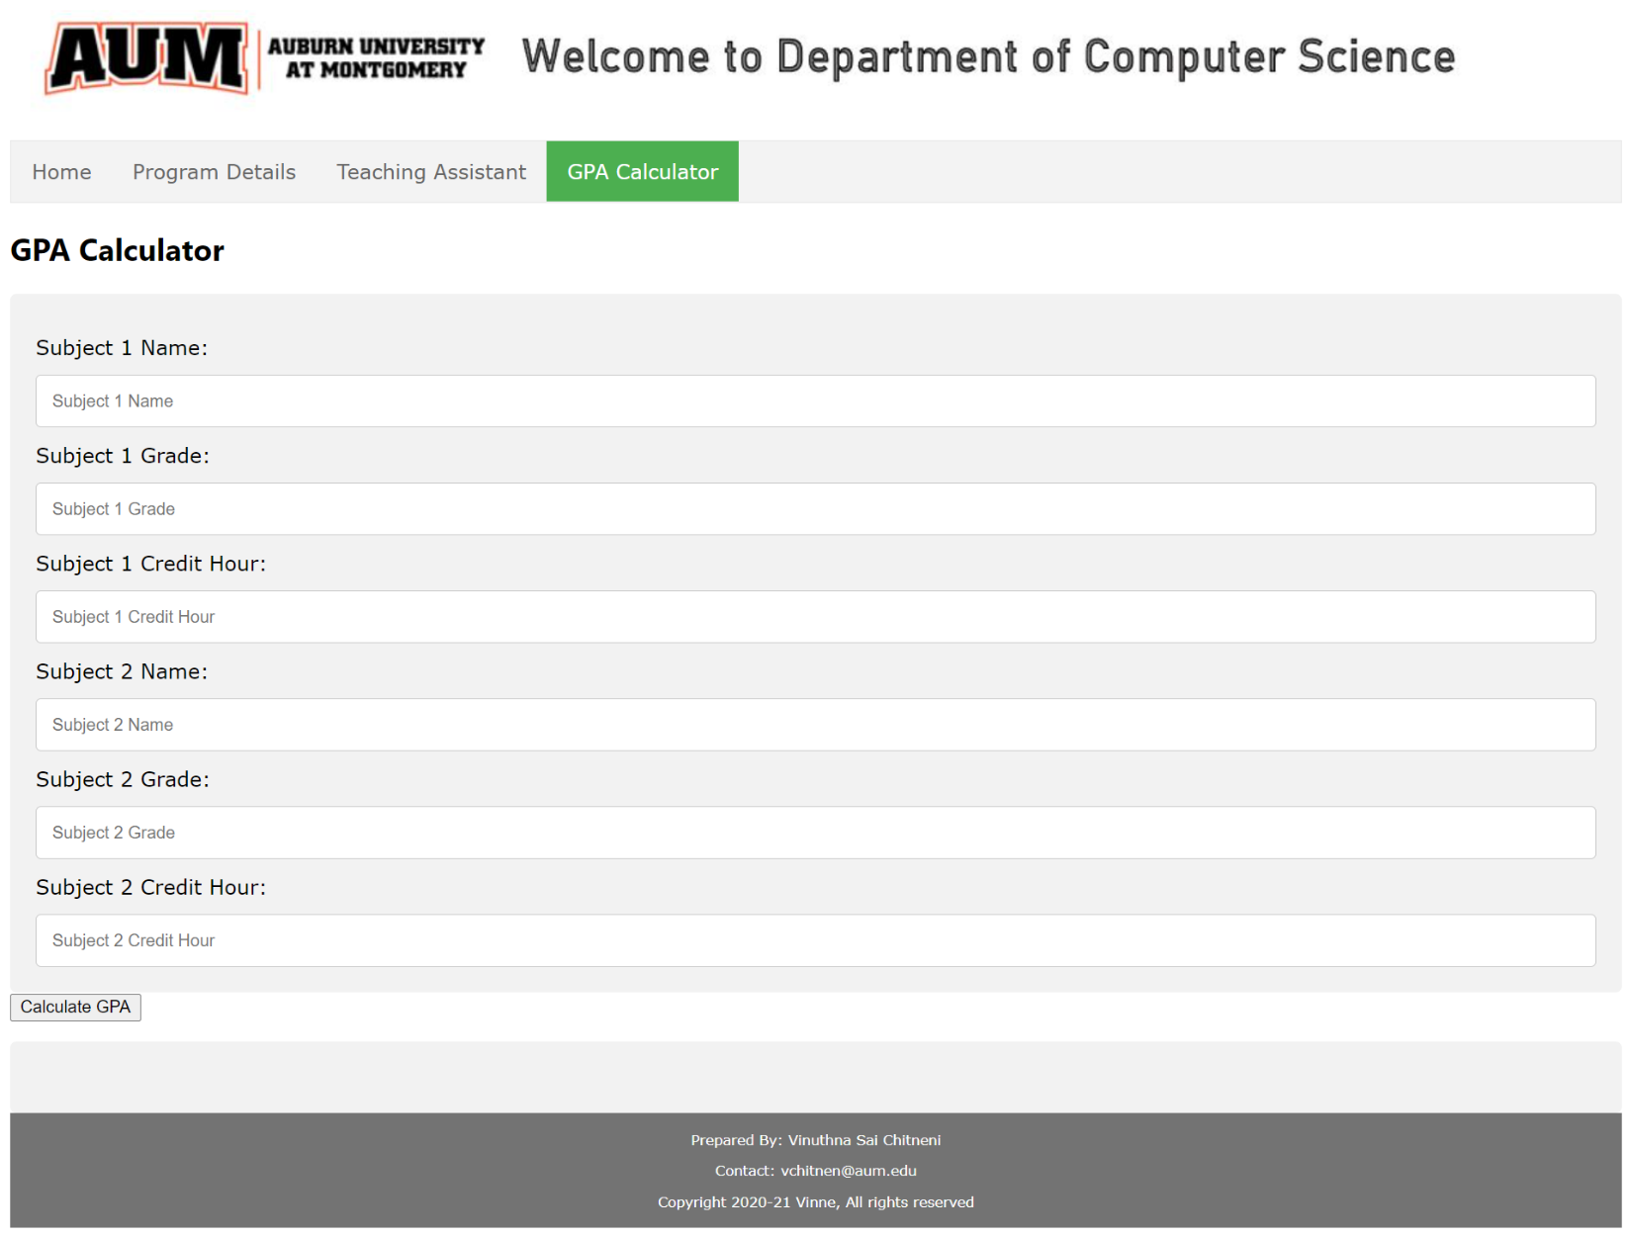

Display content of GPA calculator: